**MONGODB FINAL PROJECT**

**Name: DARA VAMSI**

**Reg No: 22BCB7293**

**Gmail: vamsi.22bcb7293@vitapstudent.ac.in**

**Project Title:**

Student Feedback Portal

**Project Description**

The **Student Feedback Portal** is a full-stack web application that allows students to submit feedback and enables administrators to securely view, manage, and delete those submissions.

**🔧 Features:**

* 📝 Students can submit feedback (name, email, department, subject, message)
* ✏️ Editable feedback form available for 5 seconds after submission
* 🔁 Option to submit another feedback immediately
* 🔐 Secure admin login via credentials stored in .env
* 📋 Admin panel to view all feedback submissions
* 🕒 Displays date and time of each submission (localized)
* 🗑️ Admin can delete any feedback from the dashboard
* 💾 Data stored persistently using MongoDB and Mongoose
* 🎨 Styled UI using CSS with EJS templating

**🛠️ Tech Stack:**

* **Frontend:** HTML, CSS, EJS
* **Backend:** Node.js, Express.js
* **Database:** MongoDB with Mongoose ORM
* **Other Tools:** .env for environment variables

Setting Up the Environment to run this.

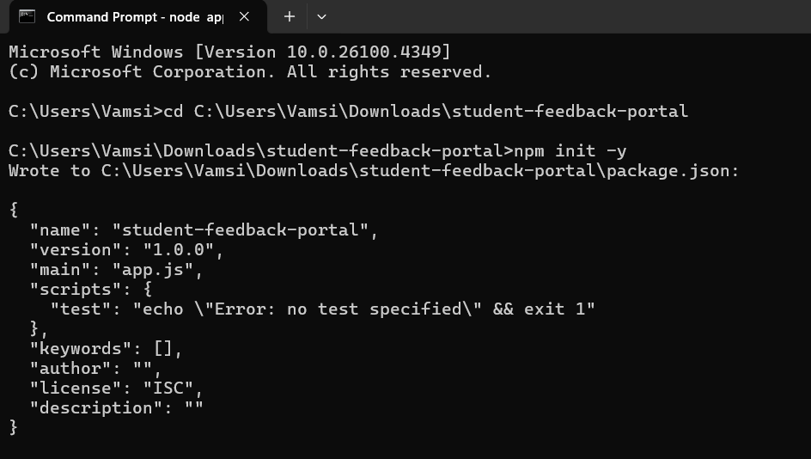

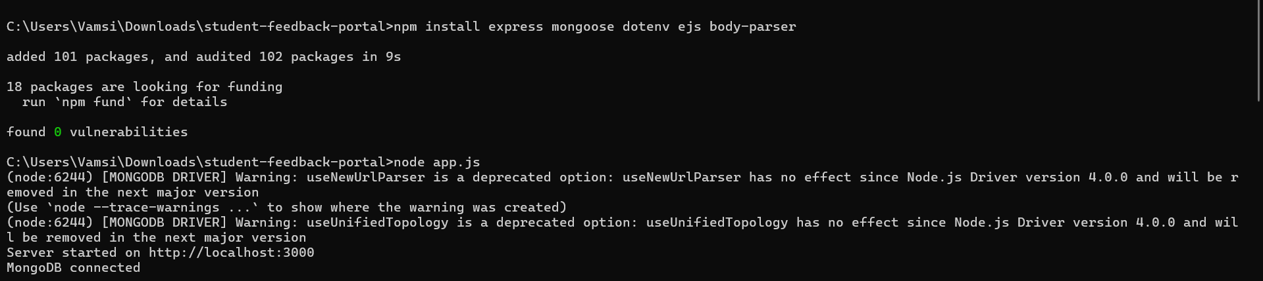

Connecting the server by entering **node app.js** in powershell/cmd

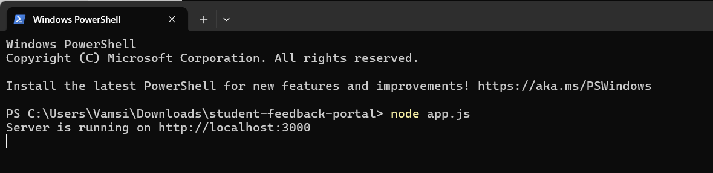

<http://localhost:3000/>

<http://localhost:3000/admin>

**Student Feedback Form**

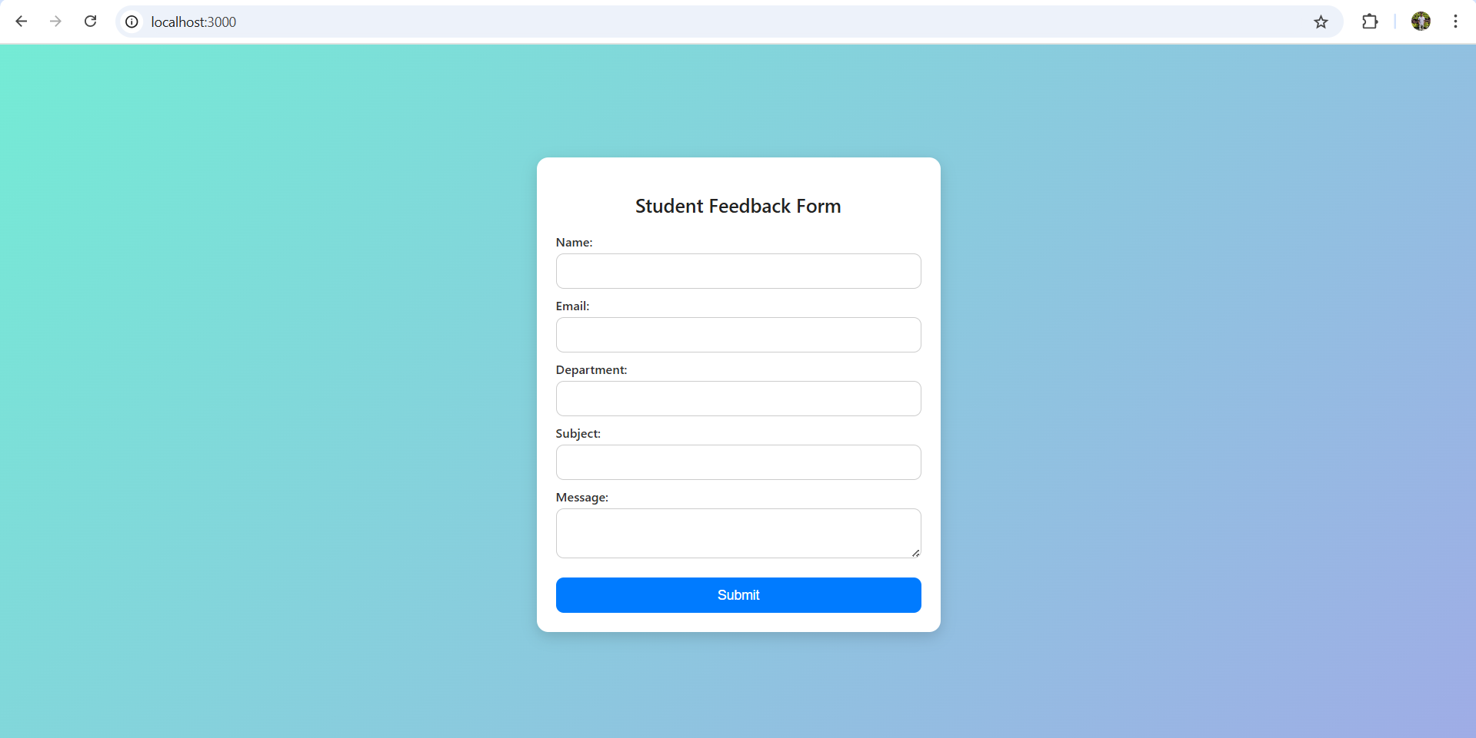

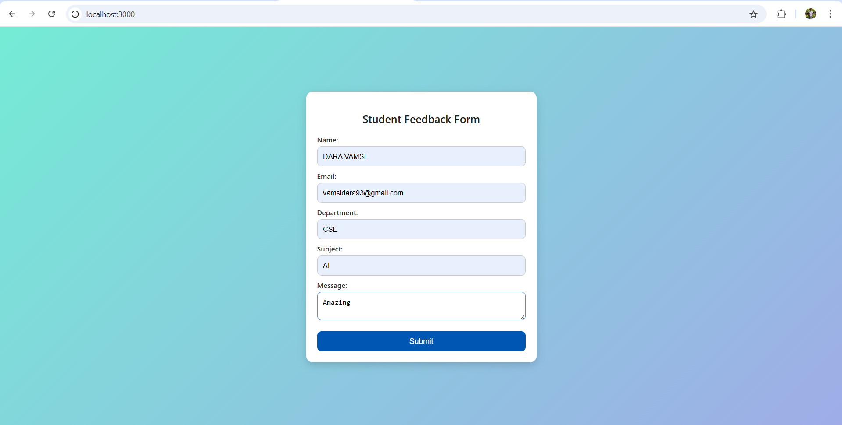

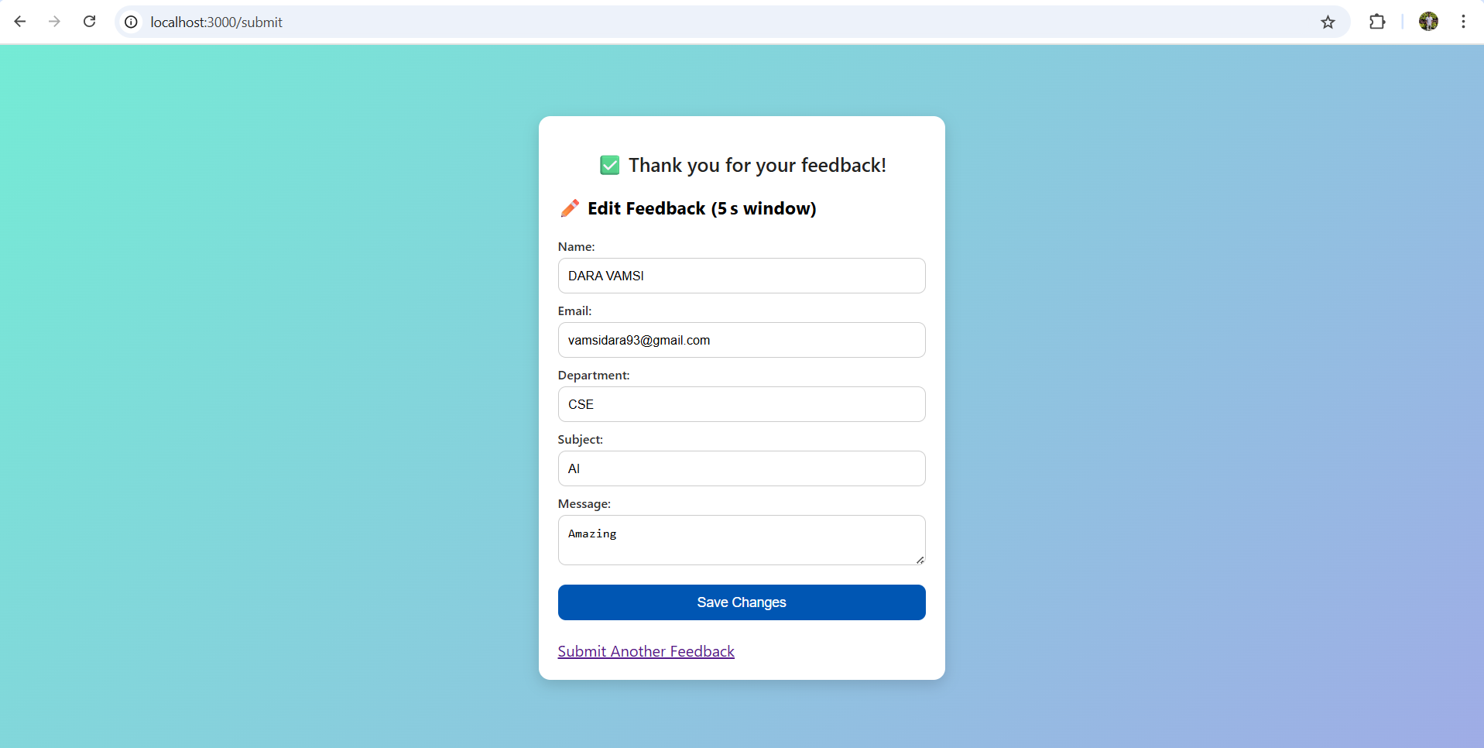 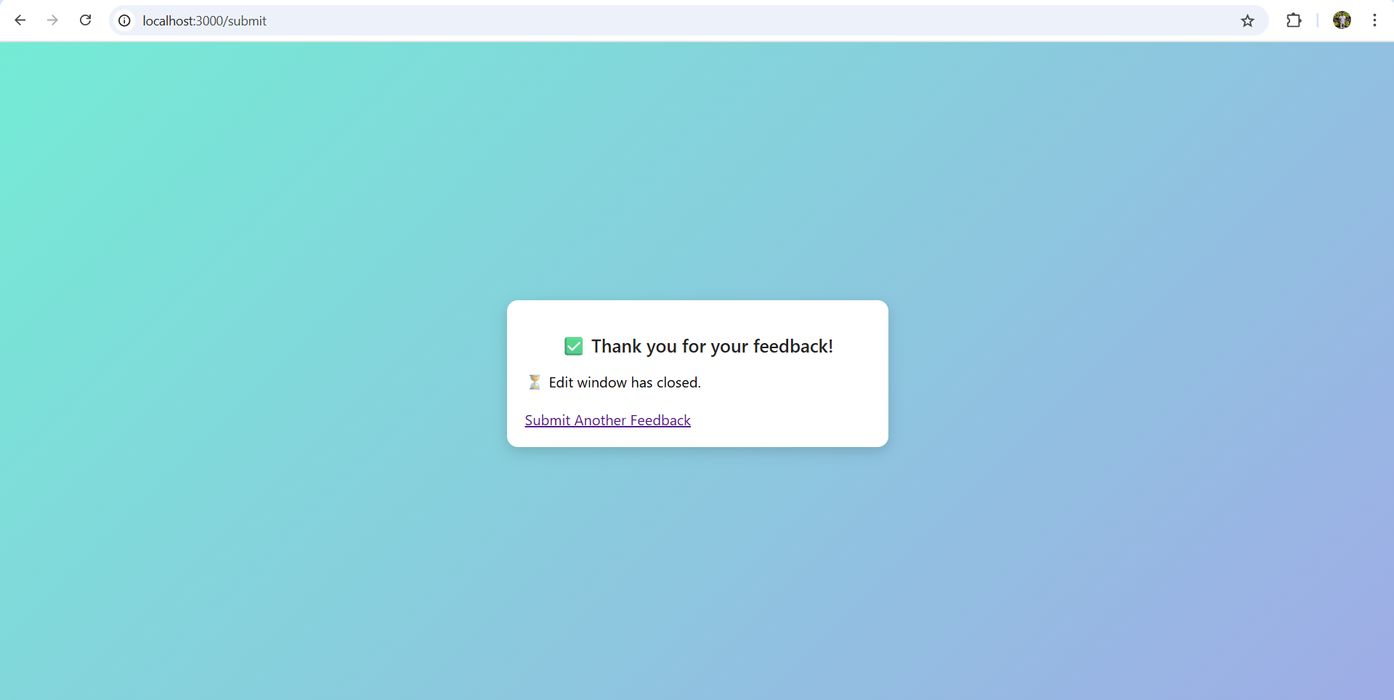

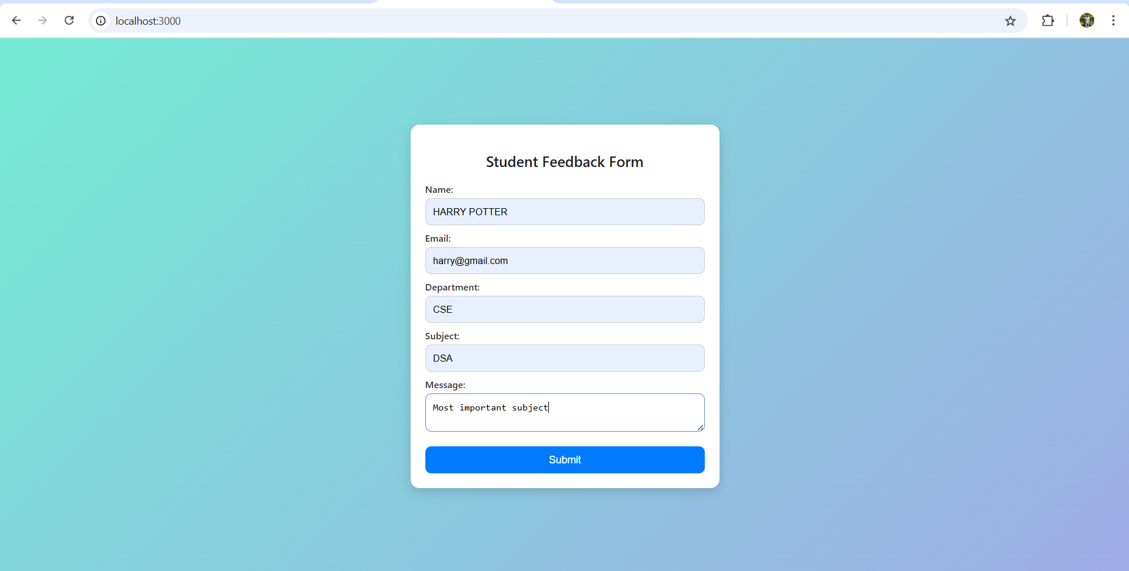

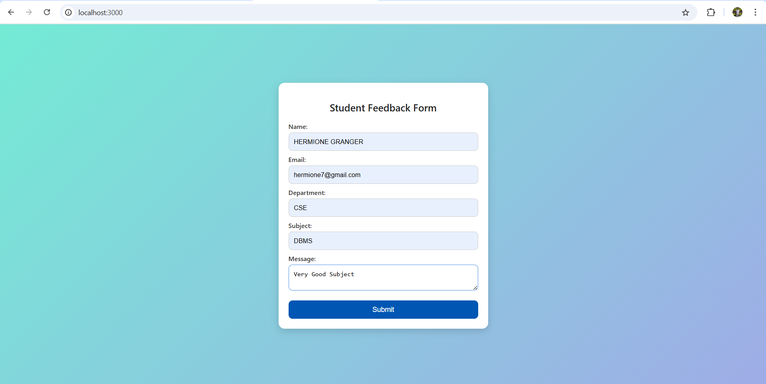

**Admin Side**

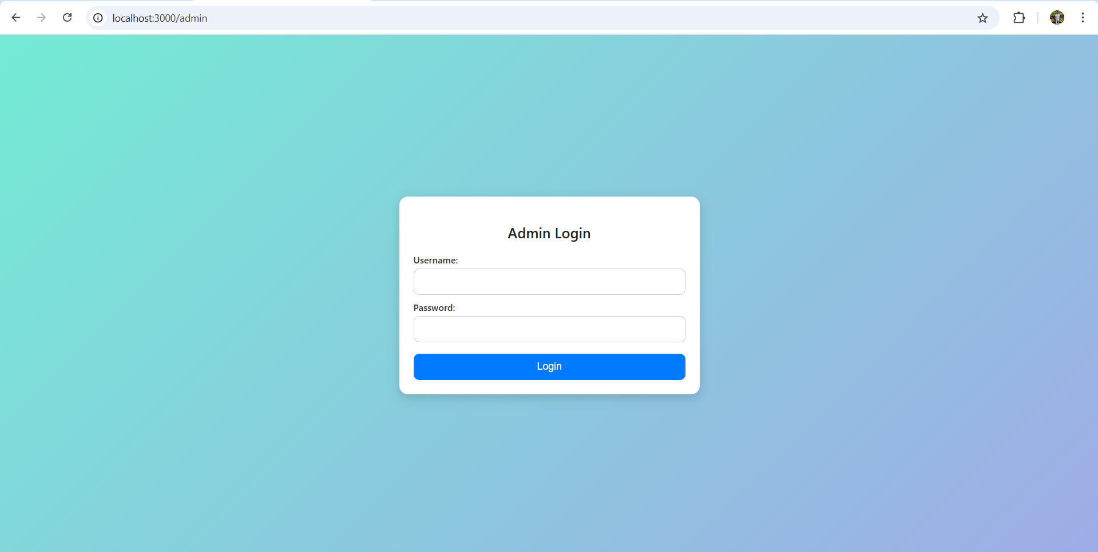

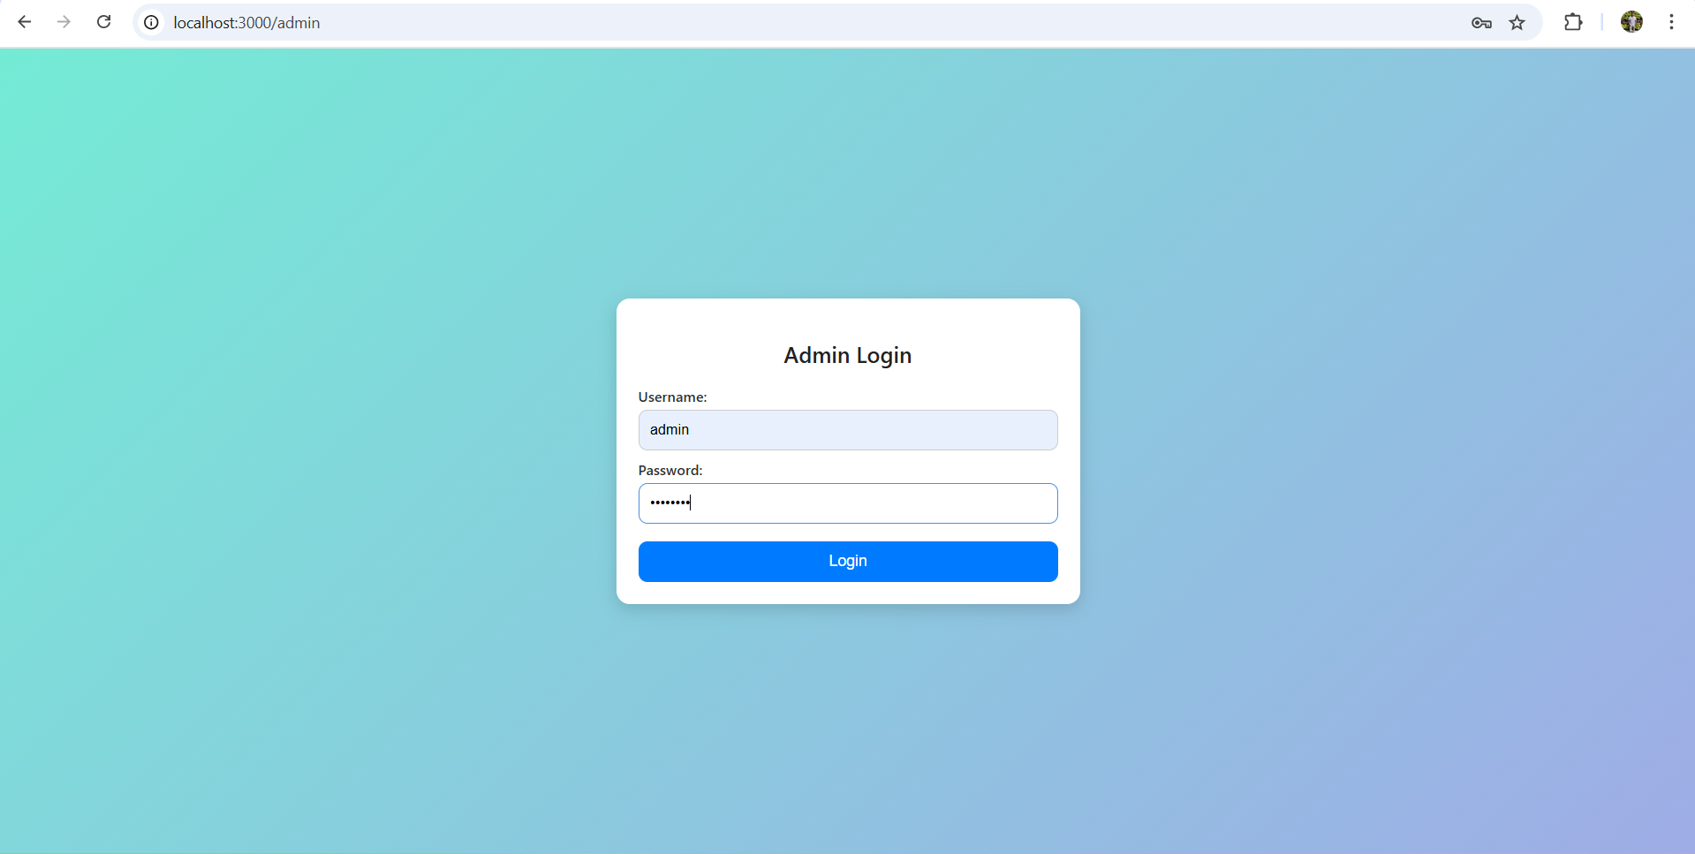

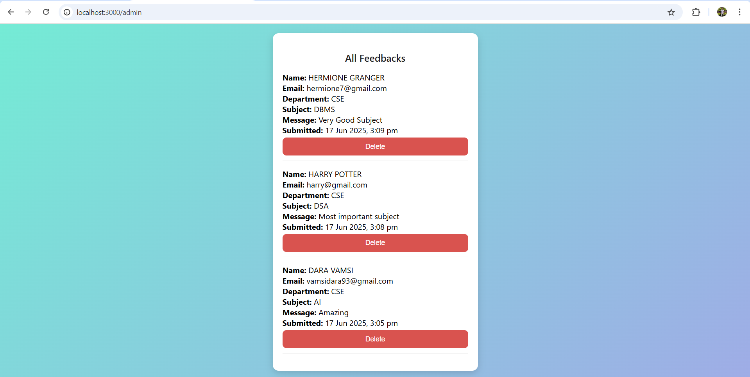

**In MongoDB Compass**

